The IARU Region 3 Newsletter

Issue 39 – Q2 2016, Released July 2016

A word from the Chairman

Work is going on in preparation for WRC19. As mentioned earlier harmonization of the 50 MHz band is the primary objective and many volunteers have been attending the different committee meetings in Geneva. It is going to be a long road.

We in Region 3 are working on improving communications with member societies. A number of suggestions have come in including an interactive section on the webpage where societies themselves can edit and change their information. The webmaster is working on this but at the moment has not had good results on a working model.

The next major event in our region is the Tokyo HamFair which will be held at the Bigsight exhibition centre on the 20th and 21st August 2016. This event attracts visitors from all over the world and is a very good opportunity for meeting old friends and making new ones.

New models of radios are usually launched during the exhibition and it is an opportunity to keep abreast of latest technology.

Several interesting meetings from various interest groups also take place during that time. The directors will be meeting in Tokyo in August immediately following the Tokyo Hamfair.

The IARU HF contest has just concluded and some directors and the secretary took part handing out the R3 multiplier. Conditions on the higher bands were very poor and scores correspondingly lower than last year.

We urge all societies to contribute news items for the newsletter- our editor has a very hard time gathering information!

Gopal VU2GMN

Amateur Radio Display on the Border

The World Amateur Radio Day Every held on the 18th of April this year is when IARU Member-Societies and their affiliated clubs show the capacity of radio amateurs and their benefit to society.

This year the Albury Wodonga Amateur Radio Club held a four day exhibition to celebrate World Amateur Radio Day. The event took place in the Albury City Library and Museum. A variety of items related to Amateur Radio including some older equipment and QSL cards were on display. The special event station VK2EWC was active on 7.120MHz, 21.210MHz, and 14.210MHz plus contact through the VK2RAY repeater. A commemorative QSL card and eQSL was available for all contacts. What a great initiative of the Albury Wodonga Amateur Radio Club. What is your club going to do in 2017?

WIA

IARU becomes custodian of operating standards booklet

Over the last eight years, the booklet “Ethics and Operating Procedures
for the Radio Amateur” has become a respected work describing the best standards of operating on the amateur bands. Translated into most major languages, the booklet by John Devoldere, ON4UN and Mark
Demeuleneere, ON4WW, is a valuable reference work for all radio amateurs. The booklet can be found at http://www.hamradio-operating-ethics.org/

Mark and John recently contacted IARU, explaining that they felt it appropriate for IARU to become the custodian of the booklet into the future, with the scope to adapt and update it to ensure it remains relevant and current.

The IARU Administrative Council accepted this offer with gratitude to John and Mark for the work they have put into the document. On May 5th 2016, Mark and John met Don Beattie, G3BJ, President IARU Region 1, in Brussels to officially hand over the document. IARU will now carry forward the work in future years to ensure its continuing relevance and currency.

Any additional information can be obtained from the International Amateur Radio Union, PO Box 310905, Newington, CT 06131-0905 USA Phone +1 860 594 0200, Fax +1 860 594 0259.

IARU

IARU Region 1 Agrees Provisional 5 MHz Bandplan

At its April 2016 IARU Interim HF Band Planning Conference in Vienna it was unanimously agreed, following a paper presented by the RSGB ’s HF Manager, Ian Greenshields G4FSU, a basic provisional Bandplan for the new 5 MHz WRC15 allocation. The plan is intentionally very simple as the band is too narrow for any detailed planning.

The following shows the proposed Bandplan and the bandwidths for the 5 MHz WRC-15 allocation for Region 1 with a view to harmonising this across all regions:

5351.5 – 5354 kHz 200Hz CW/narrowband modes
5354.0- 5366 kHz 2700Hz All modes, USB voice recommended.
5366.0-5366.5 kHz 20Hz Weak signal narrowband modes.

It is strongly recommended that frequencies within the WRC-15 allocation only be used if there are no other frequencies available at 5 MHz under domestic (I TU-R article 4.4 ) permissions. Local nets and long rag chew QSOs should not use the 5 MHz WRC-15 allocation, but should instead make use of the 3.5 MHz, 5 MHz domestic or 7 MHz bands where there is more spectrum available.

Please note the Bandplan is not valid until the WRC15 frequencies are made available by your regulator.

IARU R 1

AIST-2D and SamSat-218 satellites
Two Russian satellites AIST-2D and SamSat-218 operating in the Amateur bands were launched on April 28, 2016 at 02:01 UT on a Soyuz 2-1A launch vehicle from the new Vostochny Cosmodrome located in the Amur Oblast
The satellites were placed into a 471 km × 485 km orbit with a 97.3° inclination.
AIST-2D weighs 500 kg and is a technology demonstration and scientific research satellite developed at Samara Aerospace University. The 3U CubeSat SamSat-218 was developed by students at the Samara State University and weighs just 4 kg.
Frequency information from Dmitry R4UAB http://r4uab.ru/?p=11842
AIST-2D / RS-48 Downlinks
• 435.3065 - 435.3235 MHz Telemetry Data
• 435.3565 - 435.3735 MHz Telemetry Data
• 433 - 438 MHz 200 watt Synthetic Aperture Radar (SAR)
• 8025 - 8393 MHz Remote Sensing Data
AIST-2D / RS-48 Uplinks
• 145.831 - 145.849 MHz Control Link
• 145.861 - 145.879 MHz Control Link
SamSat-218
• 145.850 - 145.890 MHz TRXSSAU downlink
• 435.590 - 435.610 MHz TRXSSAU uplink
AIST-2D
http://spaceflight101.com/soyuz-lomonosov/aist-2d/
SamSat-218
http://spaceflight101.com/soyuz-lomonosov/samsat-218d/
432-438 MHz was allocated to the Earth Exploration Satellite Service (Active) at WRC-03
https://www.itu.int/dms_pubrec/itu-r/rec/sa/R-REC-SA.1260-1-200305-S!!PDF-E.pdf
AMSAT-UK

R3 Director gives IARU Presentation to HARTS Annual Dinner

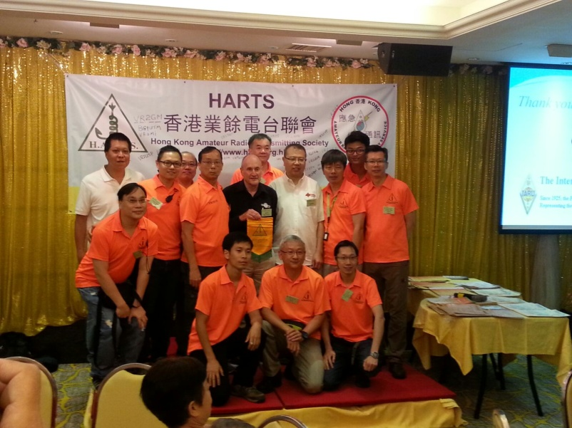

Director Peter Young, VK3MV, at the invitation from HARTS on his way home from the US, gave a presentation on the International Governance Arrangements and the Role of the IARU at the HARTS Annual dinner held 28th May this year.
In his presentation Young cover how the ITU addresses the arrangements for upcoming World Radio Conference (2019) and how the IARU organizes its response through participation in various Study Groups and conferences. Young went onto provide an overview of what the Regional Directors are currently engaged in since the last R3 Conference in Bali.

The HARTS annual dinner is very well attended by some 300 members of the Society as well as invited guests and technical presenters.

Thanks to Johnny and Sunny for the photo from the dinner.

R3 Director Peter Young

IARU Region 3 Directory

Official R3 Directory. Further information can be found on the Region 3 website: http://iaru-r3.org/staff-list/

Society Update Officials and Contact Information

A request is ext A request is extended to all Region 3 Society Liaison Officers or other responsible officers to ensure that all details about their society is up to date on the listings shown at http://iaru-r3.org/ under member societies. Some details have not been amended or updated for a number of years and have non functional data.

Current details can be forwarded to the Secretary of Region 3 for updating of the web information.

Newsletter details:
The Region 3 Web Site: Go to: http://www.iaru-r3.org.

Editor: Peter Young, Director IARU Region3.
E-mail: petervk3mv at tpg.com.au

Region 3 Societies can submit articles for inclusion to the next bulletin by 30th September 2016.

Publisher: The International Amateur Radio Union Region 3
P. O. Box 73, Toshima, Tokyo 170-8691, Japan.
Office: c/o JARL 3-43-1 Minamiotsuka, Toshima-ku, Tokyo, Japan
E-mail: secretary@iaru-r3.org
Tel: +81 3 3988-8753 Fax: +81 3 3988 8772

The statements or opinions in this Newsletter do not, unless otherwise stated, necessarily reflect the views of IARU Region 3, the Directors or the Secretariat..

Note to Editors - Items from this Newsletter may be freely copied for publication by Member Societies of IARU.

IARU Region 3
